**BRINGSTY COMMON MANORIAL COURT**

**Minutes of the Annual General Meeting**

**held on 24thNovember 2022**

**in Whitbourne village hall**

**Present:**

Catherine Fuller (chair), Tom Fisher (vice-chair), Peter Bridge (treasurer), Tim Phillips, Niall Waller, Kirsty Udall, Sally Knowles (Whitbourne PC), Cllr. Nigel Shaw (ward councillor), Jenny Creek (clerk)

Residents and Commoners also attended.

1. **Apologies for absence**

None

**2.** **Minutes of the 2021 Annual General Meeting**

These were approved.

**3. Matters arising from item 2**

None

**4. Chair’s Report**

See attached.

**5. Matters arising from item 4**

None.

The report was approved.

**6. Treasurer’s Report**

The Treasurer’s report is attached.

The treasurer explained why our accounting year runs from August – July.

**7. Matters arising from Item 6**

None.

The report was approved.

**8. Election of the committee for 2021/22**

Jenny Creek announced her resignation as clerk.

Nominations were received from:

Tim Phillips, Tom Fisher, Kirsty Udall, Peter Bridge, Catherine Fuller, Niall Waller, Martin Roote, Elizabeth Hesketh and Donna Simcox-Bird. These were all approved and seconded.

Sally Knowles confirmed that she would continue as Whitbourne representative for another year.

There were no further nominations and no objections to the nominees so the above have been elected for the current year.

**9. Appointment of Auditor**

Mr David Hunter-Miller Bsc(Hons), PSLCC, MCIHT, Clerk to Brockhampton Group Parish Council, has agreed to continue auditing our accounts and this was unanimously accepted.

The next ordinary meeting will be held on Tuesday 29th November 2022 by Zoom.

There followed a talk by David Swallow from West Midlands Fire Service on the subject of wild fires and how to protect properties from them. This was very relevant to Bringsty common as there were several fires in the summer. This talk was very helpful and interesting.

Cllr Shaw thanked David on behalf of the committee.

Finally, refreshments were served.

**Bringsty Common Manorial Court**

**AGM ANNUAL REPORT 2022**

*The mission statement for Bringsty Common Manorial Court as agreed with residents is that “Bringsty Common remains a place where residents and visitors alike can safely enjoy the physical and mental well-being from visiting or living in a peaceful and beautiful landscape.  We will enhance the sense of community, honour our heritage, increase the bio-diversity of the Common and contribute to CO2 reduction*.”

How far have we got in the last year and what are our future plans?

**Community**

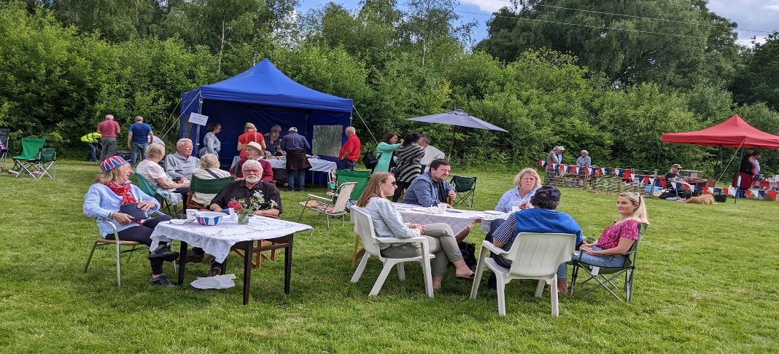

We are grateful to Whitbourne and Brockhampton Group Parish Councils in sponsoring Queen Elizabeth II’s Platinum Jubilee celebration on Bringsty Common on 2nd June 2022. The event was very successful with good attendance from both residents and visitors to the common. The afternoon event started with a ukulele band, and continued with a dog show, face-painting, games, orienteering, raffle, teas and cakes and a Bringsty and Buy stall. In the evening, after handbells, ukuleles and a musical procession, we were proud to be able to be part of a chain of thousands of beacons across the UK and overseas territories celebrating the occasion.

Prizes/vouchers for the raffle were donated from Bringty Café, Bringsty Vintage Living, Live and Let Live Inn, Sintons and Gundogs and Pencombe Private Pool. Many thanks to them.

Stalls and opportunity to raise funds were also provided to Brockhampton Parents Teacher Association, Pancreatic Cancer appeal, and local orienteering club.

Over £800 was raised from the event for Disaster Emergency Committee work in Ukraine.

Our Community has also been promoted via the Facebook site “Bringsty Folk” which now has 64 members who share information of all local matters. New this year, with thanks to Niall Waller is also the website [www.bringstycommon.org.uk](http://www.bringstycommon.org.uk) An excellent site with regular updates and records of local and Bringsty Common Manorial Court activities and history.

We are grateful to Tom Fisher for providing us with “The Commoner” news letter for a number of years and to Philippa Clayburn for taking over this role. Please let PhilippaClayburn@live.com have contributions of news, recipes etc for the next edition.

**Biodiversity and Carbon Reduction**

Biodiversity has been promoted throughout the year by planting of wildflowers and native trees and shrubs, bracken control and management of grasslands.

**Health and Safety**

The defibrillator next to Bringsty Living was previously installed by the BCMC and is available to all. Dangerous trees and dumping of a dead sheep have been reported to the landowner who has responded quickly and effectively. Serious accidents mean speed control on the A44 continues to be a concern and we now have greater enforcement and signage. On the advice of the fire brigade tracks have been and will continue to be cut to the wider width than previously, with a view to this increasing further in places. Bonfires etc which have not been agreed with the landowner are not permitted. The speaker for this year’s AGM is the national lead from the fire service on wild fires and will provide further guidance for the year.

**Heritage**

The Common has a wealth of history, including listed buildings, the Drovers Pond, the Gospel Oak and a range of native trees, all of which we strive to preserve. Residents have contributed to a book by Prof Angus J. L. Winchester, *Common Land in Britain: a History from the Middle Ages to the Present Day* (Boydell Press, 2022). Details at <https://boydellandbrewer.com/9781783277438/common-land-in-britain/>. An article from the book along with regular heritage stories and photos are being shared on the website and the Facebook site and residents are encouraged to add to these or the Commoner.

**Mental Health and Well-Being**

The widening and a planned increase of track cutting, responsible dog walking, maintenance of the bus shelter and regular litter control all contribute towards improved access to a place of peace and beauty which enhances mental health and well-being.

**Funding**

Funding has successfully been obtained in the year for the Platinum Jubilee and for the next 3 years from Herefordshire Council for continued works to promote biodiversity.

Cathy Fuller

BCMC Chair

18/11/2022

**Treasurer’s Report, 1 Aug 2021 - 31 July 2022**

The highlight of this FY was the very successful Platinum Jubilee Bash (PJB), held on the football field on a beautiful day in July. Generous donations were received from WPC/BPC, but, because it had previously been agreed, BCMC could not financially support the event. However, we did provide banking facilities for income/expenses. These items are shown separately (in pink) on the final BCMC EOY statement.

The final figures show the totals as reflected in the BCMC account with Lloyds.

To simplify receipts/payments the account has been changed to an on-line account. Unfortunately, the full advantages of on-line facilities have yet to be realised, despite many hours spent trying, I have been unable to facilitate electronic bank transfers instead of cheques.

**Balance, 1 Aug 2021: £25900.97**

Income, BCMC £3666(*) (£3000 Morgan, £250 Gigaclear £400 WPC/BPC,

£16(*) sale of tree whips)

Income, PJB £1381(*) (£500 WPC/BPC, £881(*) PJB sales)

Expenditure, BCMC £6676(*). (£2590 Mowing, etc Common, £2988 Tracks,previous year, 5x£14.39 Zoom. £107 website/audit, £240 football pitch, £495 wild flowers), Invoice (2500 est) for track 1922 still outstanding.

Expenditure, PJB: £1380(*) (includes final donation to Ukraine Appeal)

**Balance, 31 July 2022: £22,790.66**, carried forward to 1 Aug 22

(*) For simplicity, all amounts have been rounded down

All meeting have been conducted by Zoom at £14.39/meeting. rather than face-to-face meeting. . Despite the limitations Zoom is definitely a cost-effective method of conducting business.

Cost of conservation works, and track cutting is the most significant item of expenditure and needs to be closely monitored. Invoices for track cutting (est £2500) are still awaited.

Fortunately, in 21–22, we were awarded a very generous donation of £3000 by Morgan Motors. Also, they continue to print The Commoner, at no cost to us, although many copies are now sent out electronically.

This year, on the recommendation of the fire brigade, the rides have been widened, incurring extra costs. HCC have previously said that they will fund the extra costs involved (now received in 22-23). The rides are a valuable feature of BC and contribution much to the enjoyment of both residents and the increasing number of visitors.

Peter Bridge

Treasurer