**BRINGSTY COMMON MANORIAL COURT**

**Minutes of the Annual General Meeting**

**held on Monday, 23rd October 2023**

**in Whitbourne Village Hall**

**Present:**

Catherine Fuller (chair), Tom Fisher (vice-chair), Peter Bridge (treasurer), Tim Phillips, Niall Waller, Kirsty Udall, Sally Knowles (Whitbourne PC), Martin Boote, Elizabeth Hesketh (clerk)

Residents of Bringsty Common also attended.

1. **Apologies for absence**

Cllr. Peter Stoddart, Jenny Creek

**2.** **Minutes of the 2022 Annual General Meeting**

These were approved.

**3. Matters arising from item 2**

None

**4. Chair’s Report**

Chair shared current mission statement agreed in 2020 and suggested that this is reviewed in the coming year. Chair highlighted the achievement of acquiring one-off funding from two sources (i) Herefordshire County Council (HCC) and (ii) the Rural Payment Agency (RPA) and outlined how funding is being spent including goals of maintaining the Common and encouraging biodiversity (see report below).

**5. Matters arising from item 4**

Concern was raised by a Bringsty Common resident about the width and number of tracks that were being cut and the negative impact on biodiversity of uncollected cut grass (see below). Chair welcomed this contribution to the ongoing debate about how to manage the Common.

**6. Treasurer’s Report**

The Treasurer explained that Bringsty Common Manorial Court (BCMC) had access to three bank accounts two of which generated interest. Other than the one-off funding from HCC and RPA (see above) a small amount of annual income has been forthcoming from Brockhampton and Whitbourne Parish Councils for the upkeep of the football pitch.

**7. Matters arising from Item 6**

Bringsty Common resident raised issue of whether it was useful to continue to cut the football pitch as it is not suitable for playing football. However, the football pitch is a good venue for hosting outside community events. This alternate use to be highlighted when reporting back to Brockhampton and Whitbourne Parish Councils.

**8. Election of the committee for 2022/23**

Nominations were received from:

Tom Fisher, Kirsty Udall, Peter Bridge, Niall Waller, Martin Boote, Elizabeth Hesketh, Ruth Lyon and Tim Phillips. These were all approved and seconded.

Sally Knowles will continue as Whitbourne representative for another year.

There were no further nominations and no objections to the nominees so the above have been elected for the current year.

**9. Appointment of Auditor**

Mr David Hunter-Miller B.Sc (Hons), PSLCC, MCIHT, Clerk to Brockhampton Group Parish Council, has agreed to continue auditing our accounts and this was unanimously accepted.

There followed a talk by Colin Palmer, from Harlequins Orienteers, on the subject of orienteering including its history and how present-day activities are organised. The talk was informative and entertaining.

**10. AOB**

The Vice-Chair thanked Cathy Fuller for her years of service to BCMC, in particular her last four years as Chair and also thanked Jenny Creek for her many years of service to the BCMC Committee.

Refreshments were then served.

**The next ordinary meeting of BCMC will be held on Monday, 13TH November 2023 at Whitbourne Village Hall from 19;30 – 21;30.**

**Item 4: Bringsty Common Manorial Court**

**Chair’s Report for October 2023 AGM**

“*Bringsty Common will remain* *a place where residents and visitors alike can safely enjoy the physical and mental well-being from visiting or living in a peaceful and beautiful landscape.  We will enhance the sense of community, honour our heritage, increase the bio-diversity of the Common and contribute to CO2 reduction*.”

Further to a common- wide consultation the above mission statement and related priorities for Bringsty was agreed in 2020 for 5 years. How are we doing in achieving this?

One of our main achievements this year has been obtaining funding from Herefordshire Council for the **Bio-diversity plan for the common for the next 3 to 5 years.** The plan and our progress to-date is outlined below.

**Track cutting**

**Agreed Plan Nov 2022**

To be done twice a year. Cut wide with the additional width alternating from one side to the other each year where possible.

1st cut to be done when the bracken is 3-4 feet high, still soft and snaps easily. This will probably in late May/June. This will be a high cut, approximately 12 – 18 inches above ground.

2nd cut when bracken has fully regrown, between August and October.

**Progress September 2023***Tracks are being cut as planned. The first cut was a foot off the ground occurred in June 2023. This enabled wild- flowers and yellow rattle to remain in place and cleared bracken for others to be established. The second cut is planned for end of September/ beginning October 2023, which will enable seeds to be established from existing plants.*

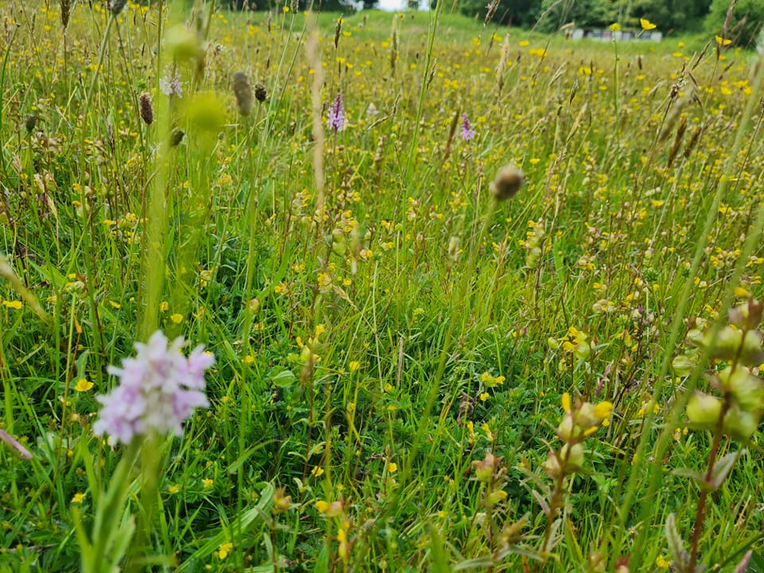**Grasslands**

Cut once a year as late as possible, no earlier than end September/October

To be collected and stored with regard to minimising the risk of spontaneous combustion.

**Progress September 2023***Cutting of the grasslands has been commissioned with this specification for the end of September beginning of October*.

**Bracken bruising**

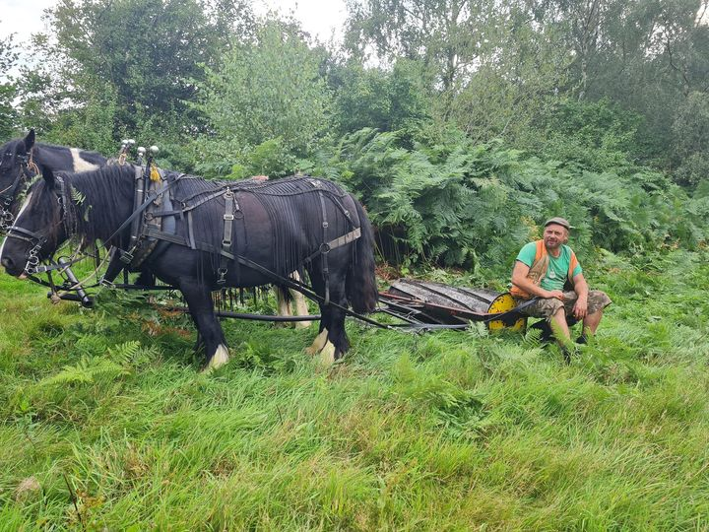

*Bracken bruising by heavy horses occurred on two sites on the common on 17th August 2023. One area, to the east of the football pitch, was heavily brackened with bracken up to 6 feet. It is anticipated that in the spring bluebells and other flowers will be now visible. Wild cherry trees are amongst the native shrubs now visible and freed to grow. The other area at the lower southern slopes of the Jubilee hill had previously been cut to grass and collected. Yellow rattle and wild-flowers were already growing here and unaffected by the bruising. It is anticipated the bruising will enhance this. The areas will be monitored for success by comparing neighbouring bracken and grassland which have not been bruised,or have been cut instead. It takes 3 years for a significant change to occur.*

*Bringsty Common Manorial Court agreed to repeat the bracken bruising by heavy horses whilst we have HCC funding. In addition to the potential benefits for wild-flowers and biodiversity, the activity was well supported by residents and visitors, who commented on the heritage of the activity. A social event is proposed on the football pitch during the activity next year and at a time when children can easily attend.*

**Wildflower and biodiversity planting**

Figure 1Devils Bit Scabious planted Autumn 2022

*Wild-flowers have been planted throughout the year. including Devils Bit Scabious, Calluna vulgaris, Salad Burnett, Tansy, Dyers , rare grasses and Calamagrostis epigeos*

*A total of 450 plugs have been planted on 3rd and 8th November 2022*

*Plugs for this year have been purchased and will shortly be planted. All planting is undertaken by a team of local volunteers, do join if you are interested.*

**Your views and monitoring progress**  
Thank you for sharing your views and sightings of new plants and wildlife on Bringsty Folk Facebook site (74 of you now belong), and on [Home | iRecord](https://irecord.org.uk/). Updates on progress are also provided at the quarterly BCMC meetings, the noticeboards and [*Bringsty Common*](https://bringstycommon.org.uk/)website.

**Looking ahead**

2023 will be the first year of our **10 year woodland improvement programme**, funded by the Rural Payments Agency.  We will be thinning and coppicing some parts of the woodland to support the existing trees and increase bio-diversity through letting more light into the rides.   We will also be exploring funding opportunities for honouring the marvellous **heritage** which is Bringsty Common.

Strengthening our sense of community is one of our key aims.  And communication is a vital element in fulfilling that aim.  So we need someone with good written communication skills to produce **the Commoner.**  The job can be tailored to suit the individual and the time available.  If you might be interested do please let me know

**Your Common Needs You.** We are looking for new members of the Manorial Court and a new chair. A nomination form is attached, and you are also welcome to express an interest or just come along and meet neighbours over light refreshments at the AGM at 23rd October 7.30 at Whitbourne Village Hall. Refreshments and a speaker from the Orienteering club will be provided.

.

Cathy Fuller

Bringsty Common Manorial Court Chair

09.09.2023

**Item 5: Concerns of Bringsty Common Resident**

I believe the recently cut tracks are both much too wide and much too numerous: even paths which were small and intimate, not firebreaks, have been turned into vast and unattractive swathes. The idea that this cutting encourages wildflowers does not hold water: to do this the cut grass would have to be collected; leaving it in place means that flowers cannot grow, and we will just have more coarse grass. Making the paths so wide, and having so many of them, uses more fuel and is therefore more expensive; furthermore, the heavy machinery causes damage to the soil structure. Many small trees have been cut down, as well as clumps of gorse, which was just about to come into flower, thus attracting many species.

I realise we must have some firebreaks, but there must also be balance, and in my opinion the recent cutting, rather than encouraging biodiversity, is likely to reduce it, as well as having made the Common a less appealing place for both residents and visitors.